CentraDatabase_Consumer MaterialMasterUpdateDDO

TIBCO Detailed Design

Author: Cognizant
Creation Date: Feb 1, 2013
Last Updated:

Revision History
Date | Description | Author/Review | Version
02/01/2013 | Initial version created – Used SCM and OTS documents as base | Krishna Karnati / Rajesh Maryada / Vineeth Attoor/ Ganesan Vaidyanathan | 1.0

Related Documents
Date | Version | Document Name | Description
 |  | CentralDatabase_Consumer MaterialMasterUpdateDDO | Technical Spec

Table of Contents
1.0 Introduction 4
1.1 Purpose 4
1.2 Audience 4
2.0 CentralDatabase_Consumer Project Architecture 5
3.0 SAPMaterialMasterUpdateDDO 7
3.1 Logical Design 7
3.2 Physical Architecture (Topology) 8
3.3 Event Flow 9
3.4 Activity Diagram 10
3.5 SAPMaterialMasterUpdateTM 12
3.5.1 Configuration Details 12
3.5.2 Use Cases 13
3.5.3 Logging and Error Handling 14
3.5.4 Mapping Detail 15
3.5.5 Business Works Component Inventory 16
3.5.6 Sign-off 17

Introduction

1.1 Purpose

The scope of this document is to provide the technical design for the interfaces in the Central-Database Consumer application TIBCO project. This TIBCO project contains all the interfaces that are a part of the OTS / SCM functional space and are used to update/ insert records in Central Database tables, which in-turn is accessed by several end-users.

.

1.2 Audience

This document contains information that can benefit developers and architects. The reader should have an understanding of EAI (Enterprise Application Integration) technology and the tools used by the HMCo Integration Center for business integration (e.g TIBCO)

CentralDatabase_Consumer Project Architecture

The Central Database is a repository of SAP published data where consumers (other HMH applications) can connect directly to retrieve the data. The Central Database is updated as soon as the SAP publishes the data, thereby ensuring a more synchronized, accurate and effective storage of SAP data. The basic design structure followed is pictorially represented below:

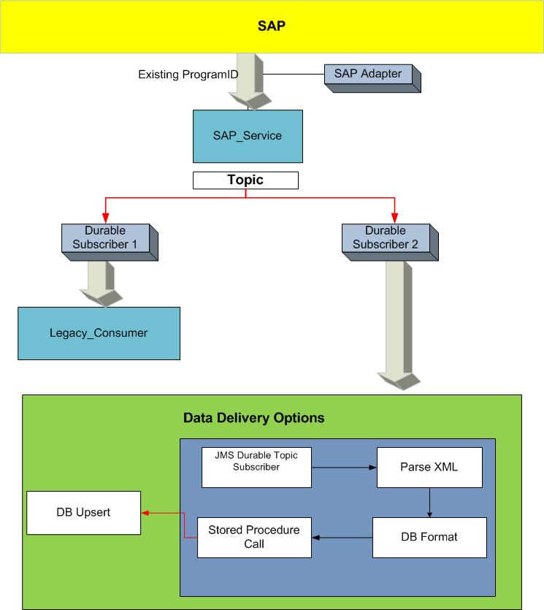
Figure 1.0 Project Architecture Diagram

Each interface is represented as a Sunrise Business Service (SBS) within the OTS / SCM space for SAP – end-user interactions. This project represents the consumer part of the interface. Below is a list of services consumed by SAP within the OTS / SCM functional area.

FRICE. ID | Interface Description | Process Name
 | SAPMaterialMasterUpdateDDO. | SAPMaterialMasterUpdateDDO

SAPMaterialMasterUpdateDDO
MainFolder: SAPMaterialMasterUpdateDDO
Processes: SAPMaterialMasterUpdateDDO

This process receives the Material Information updates from the SAP system and updates the DB tables – MAT_MATERIAL and MAT_PRODUCTHEIRARCHY. The message triggered from SAP is sent to Sunrise_CentralDatabase_Consumer by SCM_SAP_Service through TIBCO EMS. The data is updated in DB using a stored procedure call at the TIBCO service layer. The incoming SAP message is transformed into a schema consistent with the required DB format. The data is then inserted into the corresponding tables with the help of stored procedure call. The SP follows an update/ insert methodology. If the current material data is already present in the table, it would update the same. Else, a new record would be inserted in the table. The product hierarchy data is extracted from the same material idoc and inserted in the table # MAT_PRODUCTHEIRARCHY using a separate update statement in the stored procedure.

Logical Design
It shows the TIBCO project division across the OTS space.

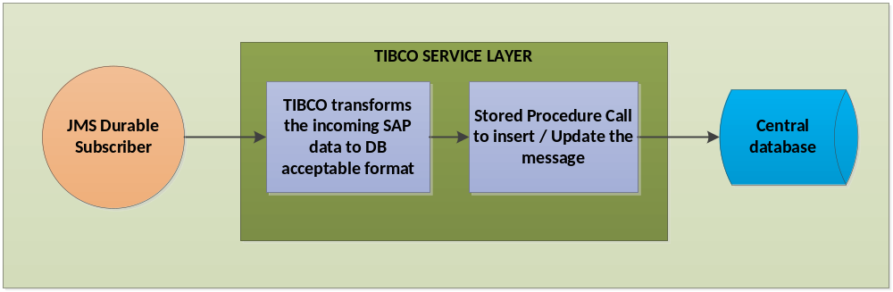
Figure 1: Logical Diagram for MaterialMasterUpdateDDO Process

Physical Architecture (Topology)

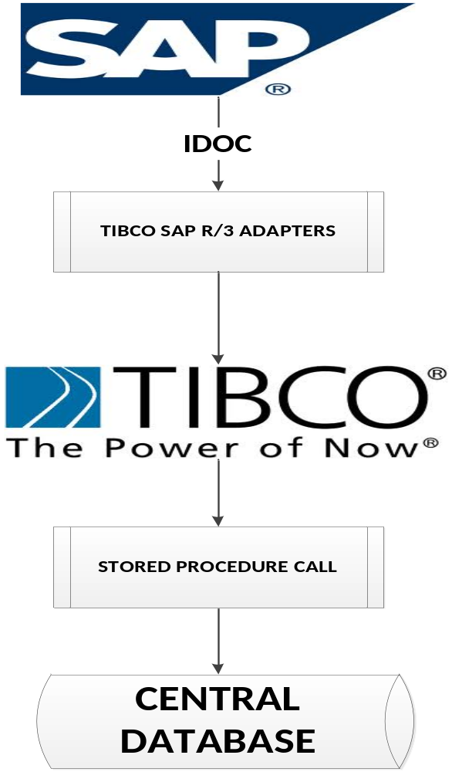

Figure 2: SAP TIBCO Physical Architecture

Event Flow

. TM will follow a similar pattern for their message flow represented in the following message flow diagram.

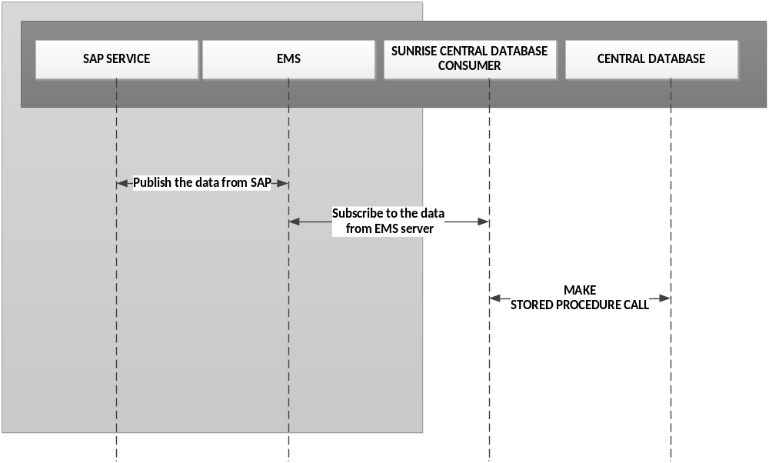

Activity Diagram

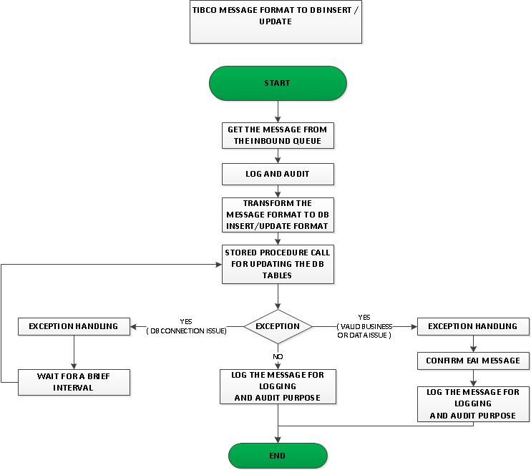

Figure 3: MaterialMaster Update Activity Diagram

Activity Detail

Activity. No. | Activity Detail
1 | Get the message from JMS durable subscriber
2 | Log the message for logging and audit purpose
3 | Transform the TIBCO message format to DB-insert specific format
4 | Make stored procedure calls at service level to insert/ update the data in corresponding DB table (MAT_MATERIAL and MAT_PRODUCTHEIRARCHY)
5 | Log the message for logging and Auditing purpose
6 | JDBC activity calls the exception process when exception has occurred in the insertion process to the DB.
7 | Confirm the message on successful insert/ update of the table. In case of a DB down error, the process waits for 10 mins for a retry and for a max of 3 times. On any data error, the message is confirmed - The issue would be analyzed and the message would be re-sent from SAP for updating the DB table.

SAPMaterialMasterUpdateTM

The material data sent by SAP is received by Sunrise CentralDatabase Consumer application, transformed to a DB-insert/updates specific format and updated in the material and product heirarchy table of the central database.

Configuration Details

Schema
Property | Value
Select Idoc | ISMMATMAS03 - ZISM_MATMAS03
SAP fields | https://eroom.dp.hmco.com/eRoom/Corporate/IntegrationSupportTeam/0_ea790

JMS Specifications
Property | Value
Transport type | JMS Topic
Delivery mode | Persistent / Durable
SSL | No

TABLES Updated | VIEWS Updated | Primary Key | Indexed Columns
MAT_MATERIAL | MAT_MATERIAL_V | MATERIALNUMBER | UPDATE_DATE_DB & ISBN13
MAT_PRODUCTHEIRARCHY | MAT_PRODUCTHEIRARCHY | NOT DEFINED | MATERIALNUMBER

Use Cases

The following use cases trigger the interface for the Customer Update

Use Case Id | Use Case Description
TM_01 | The material data sent by SAP is received by Sunrise CentralDatabase Consumer application, transformed to a DB-insert/updates specific format and updated in the material and product hierarchy tables of the central database.  .

Logging and Error Handling

Sensitivity Requirement for Logging - No
All TIBCO projects log messages and errors to a central core technical services project. Every event that crosses the TIBCO boundaries is logged. Exceptions are also logged. Below is a list of exceptions that will be handled by this process

Please see the HMCo Core Technical Services document for further details for the logging and exception service.

Activity | Exception Scenario | Exception Type | Comments
JDBC Update | DB down or connection issue | System | When DB is down, the service would wait for a brief interval and retry inserting records in the DB
Mapper | Data transformation | System | There should be a proactive error acknowledge sent to the TIBCO support staff that includes some sort of descriptive text of the problem & the specific field or rule that has failed

Mapping Detail
https://eroom.dp.hmco.com/eRoom/Corporate/IntegrationSupportTeam/0_ea790

Business Works Component Inventory
The components used or updated as part of this specification will be selected and configured based on the detailed information captured in the activity diagram and activity diagram description. The same is true for the processes that will be generated or called as part of the specification.

In order to follow best practices for single-source data, the information will not be re-captured in this document. Rather, the information will be available through svn comments in versioning tool. TortoiseSVN is an Apache™ Subversion (SVN)® client, implemented as a windows shell extension. It's intuitive and easy to use, since it doesn't require the Subversion command line client to run. All changes made in the current code would be checked in with appropriate version comments.

Sign-off

Name | Role | Date | Signature
 | Spec Writer
 | Process Owner
 | Etc…

